9 The Curve Pen Tool Part 1

Note, I have just updated my Blender up to the 4.4 version, before starting this project. This is the latest update, for this application at this time.

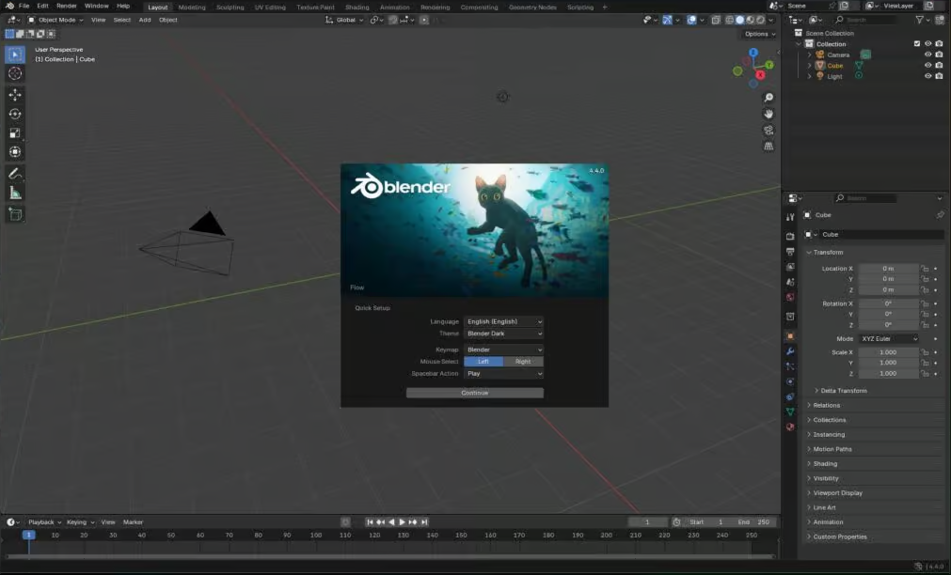

# Setting Up for the Project

You will only find this Curve Pen Tool, if you have added a Curve, in Object mode, before entering Edit mode. If you have something like the cube, and brought that into edit mode, you will not even see this tool in the tool box.

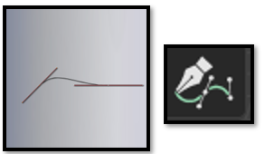

We are going to start off in Orthographic Front View. In Object Mode. You may want to move the red line of the floor for the curve down a bit, so we can have a starting point for the project. In this project we will be making a coffee cup.

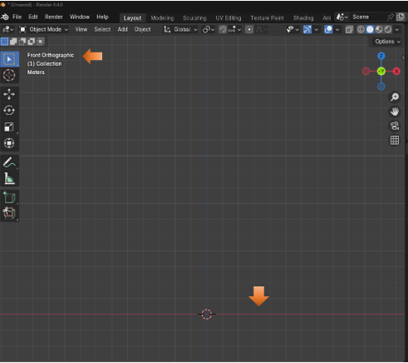

Make sure you have the Add Curve Extra Objects enabled in the Preference Menu. You can find Preference in the Edit Top Menu Button.

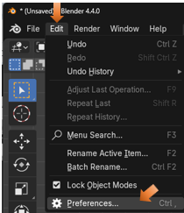

Click on the Add-Ons in the panel on the left-hand side, and then find and check, Extra Curve Objects, from the list.

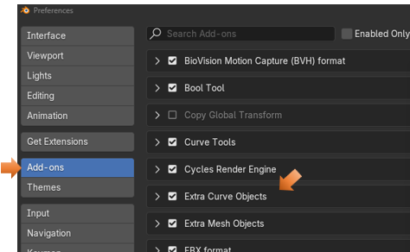

# Adding a Point in Object mode

We want to get rid of the cube that is sitting there, so just hit the X key and delete it. Now we want to add a point. Not a curve, but a point. So, for that we go to the Add menu, go to Curve, and then come down to Simple, you will find the point in the Simple menu.

Add-Curve-Simple-Point.

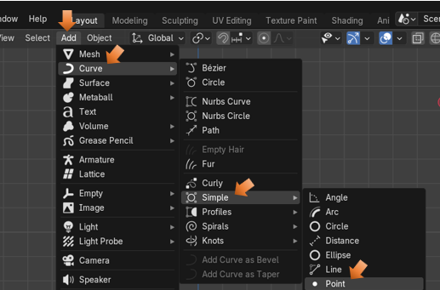

Adding this point will throw you immediately into Edit Mode. And since the point was drawn from the Curve menu, it also gave you all of the tools that a normal curve will give you. You should see that your point came in exactly where the cursor was located a the center of the Blue and Red grid lines.

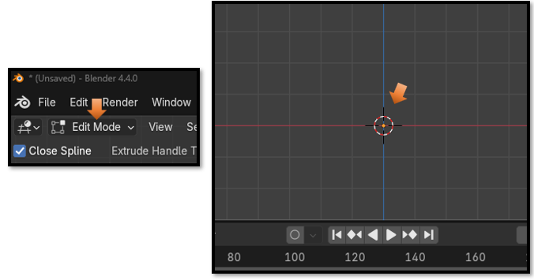

# The Last Operation Box

As soon as you reach the edit mode with your point, you will have access to the Last Operation Box. It will say Simple Curve, because this is your last operation. A creation of a point, which is the simplest of all curves.

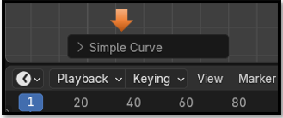

We want to make sure that we have 3 things checked in this area.

Bezier

3D

Vector

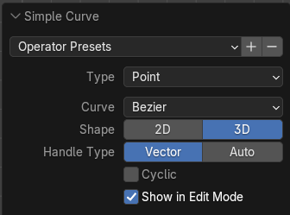

# Extruding the Point

With this curve, we are starting with a single point. But as I have said before, since we used the curve menu to create this point it is still considered a curve, and it has given us all of the tools in edit mode that we need to work with a curve.

To extend this point into a curve, we could use the Curve Pen tool, or we could hit the E key to extend it. What we would like to do is to give our selves the rough outline of what we want this coffee cup to look like. So, just start hitting the E key and then extend the segment in the direction that you want it to go.

While dragging after hitting the E key, we can hit the X key to get the drag to constrain to the horizontal X axis to create the base of this cup.

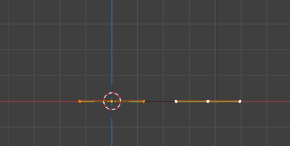

You want to click to select the middle point of each control that you make, the Hit the E key and try to mimic the best that you can the shape of a coffee cup.

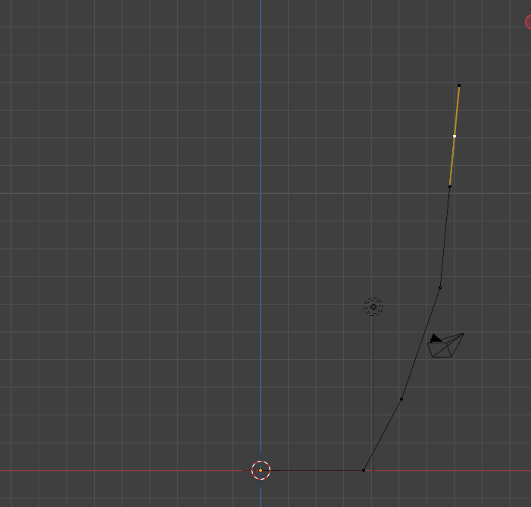

# How to Make the Segments more Curvey

We want to select this curve here on the outline of the cup. Click one time on that middle point to activate it and then we can work with that point.

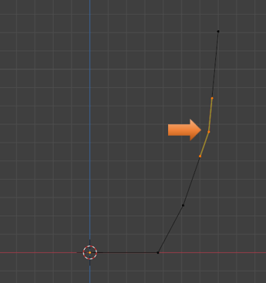

Now with that middle point selected, hit the V key, and change the handle type to Automatic.

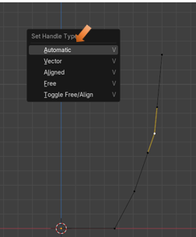

Notice with this change that the control becomes ramrod straight, but the curve underneath of it softens.

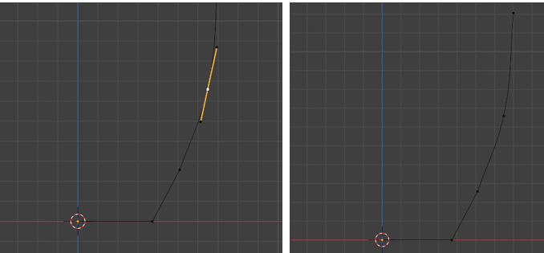

Click once to activate the control, this time the top control, click a second time on the handle, and then hit the G key to move the point on the handle we selected. So, you are essentially activating the curve first by hitting the point on the curve, it will turn into a control with two handles, you select which part of the control you want to work with. You select that part, and then hit the G key to move it.

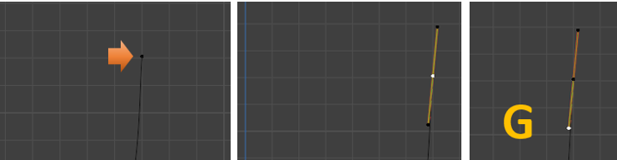

# Creating the Lip at the top of the Cup

<https://www.youtube.com/watch?v=APxkUd7OAAk>

